**Assignment 2**

1. Create a file like nano file1.txt

File created with name file1.txt



1. Data copied from file1.txt to file2.txt

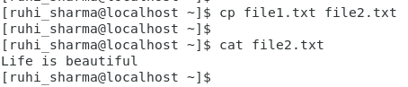

1. Created a new folder and moved file2.txt to this folder

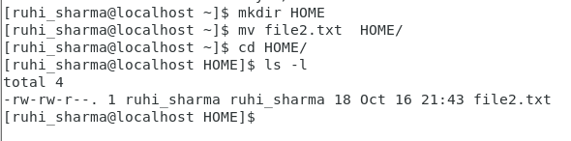

1. create a new file3.txt and file4.txt

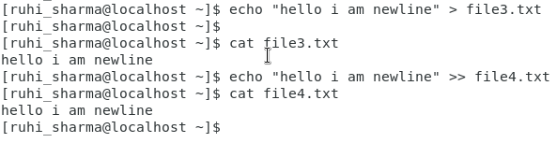

In first command > will create the file if does not exist and if it exist it always override the content in file3.txt file where as >> will create the file if does not exist and append the content/data into the existing file without over writing the existing data

1. removing file and directory
2. removing file

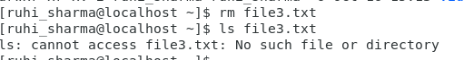

1. removing HOME directory

